Simulated Assessment Task 3.1 – Support Worker Briefing Document

Dear Volunteer.
Thank you for agreeing to participate in the candidate’s assessment.
The candidate’s assessment includes a role-play activity in which you will take part.
To fulfil your role in the activity, review this Briefing Document carefully. Discuss any queries you may have about this document with the candidate’s assessor or training organisation.
Thank you very much, and have a good day.

Your Role
You will act as the other support worker who will help the candidate in assisting the client. The candidate will act as the client’s support worker.

Volunteer Instructions

Before the activity
- Read this Briefing Document and other relevant simulated documents. The candidate’s assessor will also walk you through these documents.
- Raise any questions or concerns you may have about this document or the role-play activity with the candidate’s assessor.

During the activity
- Have this Briefing Document with you during the role-play activity.
- Participate in the role-play discussion. Follow the cues and scripts provided in the Discussion Guide section of this document.

Background

Case Study – Mobility Equipment
SCENARIO
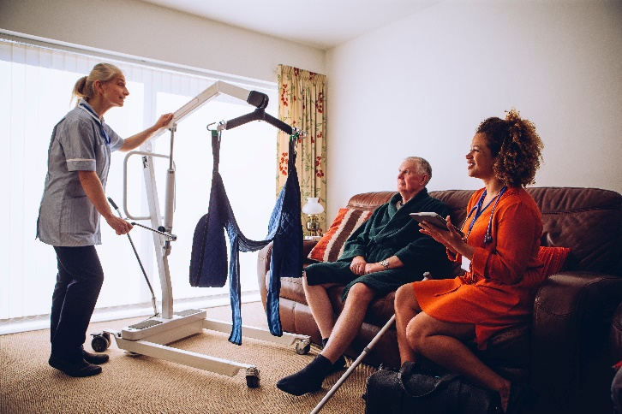
In this part of the assessment, the candidate has been requested to demonstrate the use of the following equipment to a number of trainees at CareConnect College:
- Slide sheet
- Hoist with slings
- Stand up lifter

Scenario
SCENARIO
While being observed by the assessor, the candidate will demonstrate the use of the following equipment:
- Slide sheet
- Hoist with slings
- Stand up lifter

Role Play Discussion Guide
General Disposition
- The candidate will facilitate different support activities.
- Throughout this task, you must do the following:
  - Respond timely and appropriately to the candidate’s requests and cues
  - Ask for clarification on any confusing statements, requests and cues
  - Refrain from making unnecessary remarks.
  - Refrain from introducing new elements into the scenario by reporting hazards and risks that are not stated in this document.

Part I – Repositioning the Client on the Bed Using Slide Sheet
- The candidate will ask you to assist in this transfer
- The candidate will communicate with the client.
- The candidate will greet the client.
- The candidate will explain what will happen in the support activity.
- The candidate will ask the client if they have any questions or concerns.
- The candidate will ask for the client’s cooperation.
  - You must listen to what the candidate is saying.
- The candidate will prepare the slide sheets.
- The candidate will use the log roll method to position the sheet under the client.
- The candidate will bend the client’s knee and roll the client towards them.
  - You must assist in rolling the client
- The candidate will ask you to insert the slide sheet from behind the client
  - You will gently insert the slide sheet under the client’s body
- The candidate will gently roll the client onto their back
- The candidate will ask you to bend the client’s knee and roll them back towards you
  - You must bend the client’s knee and roll the client’s back towards you.
- The candidate will insert the other side of the slide sheet from behind the client.
- The candidate will ask you to gently roll the client onto their back.
  - You must gently roll the client onto their back.
- You and the candidate will hold the top sheet close to the client’s body at the upper thigh and shoulder level
- You and the candidate will communicate when starting the movement
  - You must coordinate with what the candidate is saying
- You and the candidate will safely slide the client up the bed using the slide sheets
  - You will do what the candidate is exactly doing
- You and the candidate will refrain from lifting the slide sheets

Part II – Repositioning the Client from the Bed to the Chair Using a Hoist with Slings
- The candidate will ask you to assist in this transfer
- The candidate will communicate with the client.
- The candidate will greet the client.
- The candidate will explain what will happen in the support activity.
- The candidate will ask the client if they have any questions or concerns.
- The candidate will ask for the client’s cooperation.
  - You must listen to what the candidate is saying.
- The candidate will prepare the slings.
- The candidate will position the slings under the client
- The candidate will adjust the bed to a safe and comfortable height
- The candidate will place the client’s arms over their chest
- The candidate will ask you to bend one of the client’s knees
  - You must bend one of the client’s knees
- The candidate will gently roll the client towards them
- The candidate will ask you to insert the sling from behind the client
  - You must insert the slings from behind the client
- The candidate will gently roll the candidate onto their back
- The candidate will assist the client to roll to the opposite side
  - You will assist the candidate
- The candidate will spread the slings into position
- The candidate will prepare the sling for attachment to the hoist
- The candidate will pass the leg straps underneath the candidate’s thighs
  - You must assist the candidate in passing the straps
- The candidate will clip the slings to opposite sides
  - You must assist the candidate in clipping the slings
- The candidate will position the hoist and bring it closer to the client
- The candidate will adjust and lower the spreader bar to attach the slings to the top and bottom parts of the spreader bar
  - You must hold the spreader bar while the candidate attaches the slings
- The candidate will assist in transferring the from the bed to the chair by lowering down the height of the bed
  - You must support the client’s head
- The candidate will slowly raise the sling using hoist controls
  - You must hold the sling while it is being raised
- The candidate will adjust and reposition the sling.
  - You will assist the candidate in moving the hoist toward the direction of the chair
- The candidate will position the client over the chair while slowly bringing the hoist down
- The candidate will ask you to support the sling while being lowered down
  - You must support the sling while being lowered down
- The candidate will slowly guide the sling to position the client to the chair
- The candidate will ask if the client is comfortably sitting
- The candidate will remove the sling out from the client’s legs and will ask them to lean forward.
  - You must assist in holding the sling
- The candidate will pull the slings from behind the client
  - You must assist in holding the sling

Part III – Assisting the Client in Standing Up Using a Stand-Up Lifter
- The candidate will ask you to assist in this transfer
- The candidate will ask you to assist in this transfer
- The candidate will communicate with the client.
- The candidate will greet the client.
- The candidate will explain what will happen in the support activity.
- The candidate will ask the client if they have any questions or concerns.
- The candidate will ask for the client’s cooperation.
  - You must listen to what the candidate is saying.
- The candidate will assist the client in sitting down.
- The candidate will prepare the slings.
- The candidate will assist the client in wearing the sling by asking them to lift their arms.
- The candidate will place the sling around the client’s waist and under their arms and gently fasten them.
- The candidate will ask for your assistance in wrapping the slings around the client’s body.
  - You must assist in wrapping the slings.
- The candidate will ask the client to bring their arms down.
- The candidate will ask for your assistance in accompanying the client while they position the stand-up filter
  - You must stay with the client
- The candidate will position the stand-up lifter by widening the leg of the lifter and bringing it slowly in front of the client.
- The candidate will assist the client in lifting their legs and putting them on the footplate.
- The candidate will bring the lifter closer, so the client’s knees are close to the kneepads.
- The candidate will ask the client to lean forward.
- The candidate will attach the loops of the slings on the hooks of the lifter.
- The candidate will ask the client to lean back and hold on to the handles of the lifter.
  - You must assist the client as they gently lean back and hold on to the handles.
- The candidate will inform the client before adjusting the height of the lifter.
- The candidate will turn on the switch of the stand-up lifter.
- The candidate will ask the client to gently push their legs down.
  - You must assist the client as they get up
- The candidate will gently move the stand-up lifter from the place to the transfer point.
- The candidate will assist the client in sitting down.
- The candidate will let the client know that they are already in the transfer point.
- The candidate will ask for your assistance as the lifter goes down
- The candidate will slowly lower down the lifter and ask the client to lean forward while they remove the slings from the hooks.
  - You must assist the candidate in removing the slings from the hooks
- The candidate will then ask the client to sit back.
- The candidate will lift the client’s feet up and move the lifter away from them.
- The candidate will assist the client in removing the slings and will ask them to lean forward.
- The candidate will now remove the sling from behind the client.
  - You must assist in removing the slings.

End of Briefing Document

